## horizontal line

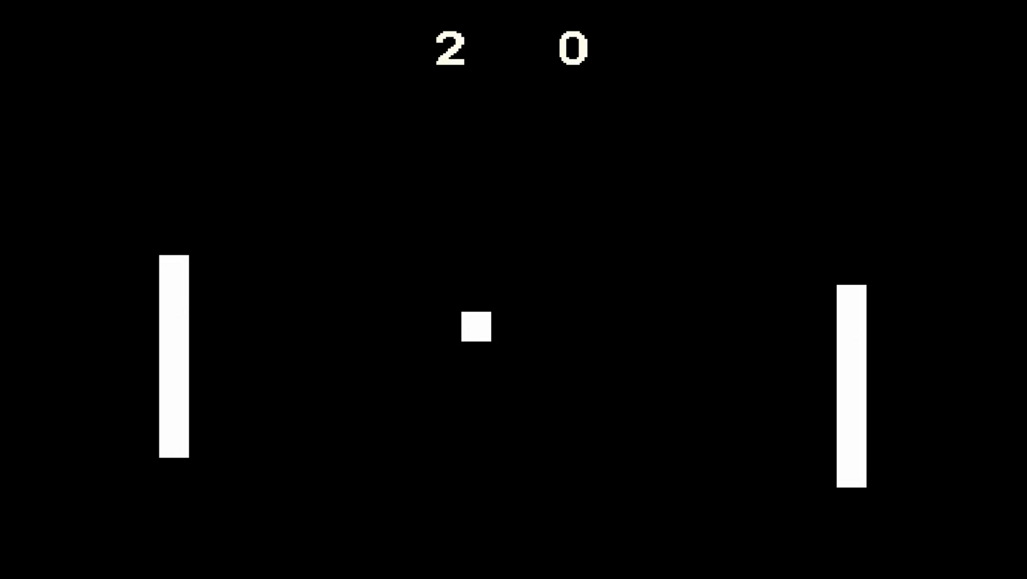

The Ultimate Pong

11.18.2018

**─**

Gabriel Rivera & John Laschober

Lewis University

1 University Pkwy

Romeoville, IL 60446

# Overview

This Project will consist of a game called *The Ultimate Pong,* where multiple users can play pong against each other like never before.

# Goals

1. Be able to implement a basic pong game using HTML5
   1. Be able to create the Basic Pong Game that everyone knows
2. Implement Multiple players (Locally or Online)
   1. If done Locally players will all play on one computer
   2. If done Online players will play on their own computer using the arrow keys
3. Implement Level Changes upon Player Count (2 Player Arena will look different than a 3 Player Arena)
   1. 2 Players will be a basic Pong Layout
   2. 3 Players will be a Triangle Layout
   3. 4 Players will be a Square Layout
   4. 5 Players will be a Pentagon Layout
   5. (Max 5 Players)
4. Implement a Lobby
   1. Players are able to create their own custom lobby
   2. Players can join anyones lobby unless private
   3. Game starts once the leader decides to start the game
5. Implement Multiplayer using a MEAN Stack
   1. mongoDB
   2. express
   3. AngularJS
   4. nodeJS

# Specifications/Complications

We will have to figure out how to implement a MEAN stack onto azure, and if azure even supports a MEAN stack. If it doesn’t, we will have to figure out how to run a server locally on our computer so others can connect to a particular computers IPv4.